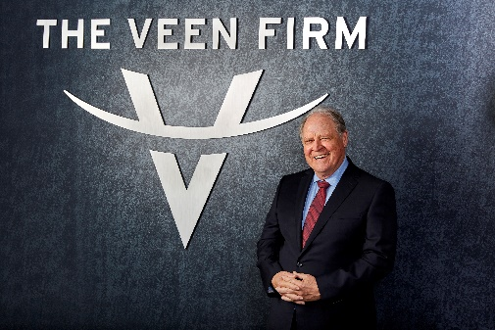 | William L. Veen  Founder & Principal Since 1975  20 Haight Street 415-673-4800 phone  San Francisco, CA 94102 415-771-5845 fax

Bio
William L. Veen oversees the operation of The Veen Firm and focuses his energy on mediations and trials of complex cases. He founded The Veen Firm, P.C. in 1975 and developed the firm from a one-man operation to a firm with over 20 members today. Mr. Veen has represented injured workers and consumers in recovering damages arising from industrial accidents, construction accidents, elevator accidents, motorcycle accidents, defective products, professional liability, and auto and truck accidents.  Mr. Veen was born in Grosse Pointe, Michigan. He served as Lieutenant for the United States Coast Guard Reserve as a Legal Specialist. He was awarded the Coast Guard Achievement Medal and represented parties in numerous court martial and Investigative Board procedures. He left the Coast Guard in 1972 with the rank of Lieutenant Commander, U.S. Coast Guard Reserve.  In his free time, he enjoys motorcycling, skiing, scuba diving, and hiking. | EDUCATION  - University of Michigan Law School at Ann Arbor, Ann Arbor, Michigan  - J.D. - 1968  - Michigan State University  - B.A. – 1965  BAR ADMISSIONS  - California, 1969  - Hawaii, 1971  AREAS OF PRACTICE  - Construction Accidents  - Workplace Injuries  - Personal Injury Accidents  - Dangerous Property  - Defective Products

Publications
- “Fair” Warning: How to Traverse a Products Liability Pitfall, November 01, 2013
- Looking Beyond the Driver’s Seat to Find Liability in Motor Vehicle Accident Cases, October 01, 2013
- Course and Scope of Employment, May 01, 2013
- iPad Apps: Getting Your iPad to Help with Voir Dire, February 01, 2013
- Sophisticated Users Have Rights, Too, November 01, 2012
- Don’t Let a Remains-Mishandling Case Haunt You, August 01, 2010
- Staffing Agency Employees Injured on the Job: A Double-Edged Sword, July 01, 2010

Speaking Engagements
- CAOC Don Galine Travel Seminar, Mylomalacia, Disc Fracture, And Other Puzzling Orthopedic Spinal Disability Causation Issues, November 2018
- CAOC Hawaii Seminar, “Thematically Trying Voir Dire, Opening Statement and Closing Argument,” Speaker, November 2017
- CAOC Annual Convention, “Masters in Trial,” Speaker, November 2017
- CAOC Hawaii Seminar, “Accident Reconstruction in Bicycle Injury Cases,” Speaker, December 2015
- Consumer Attorneys of California, Frequent Lecturer
- San Francisco Trial Lawyers Association, Frequent Lecturer

Honors and Awards
- “Lawyer of the Year”, The Best Lawyers in America – US News & World Report, 2014 – Selected by his peers in the field of Personal Injury Litigation – Plaintiffs, San Francisco
- Selected to Northern California Super Lawyers List, 2003-2015 – Top 5% of attorneys, as voted by peers
- Rated AV-Preeminent for Ethical Standards & Ability – Martindale-Hubbell, 2014
- Selected to The Best Lawyers in America – US News & World Report, 2006-2019 – Selected by his peers in the field of Personal Injury Litigation – Plaintiffs
- Verdict honored in California’s Top Verdicts of 2011, The Recorder – Chris Corbo v. New United Motor
- Nominated for San Francisco Trial Lawyers – Trial Lawyer of the Year, 2011
- Largest injury verdict in Marin County history, 2010, Travis v. Bison Builders, Inc.
- Top 100 Northern California Super Lawyers, 2006-2011
- Winner, San Francisco Trial Lawyers – Lifetime Achievement Award, 2008
- Winner, San Francisco Trial Lawyers – Trial Lawyer of the Year, 2003
- Coast Guard Achievement Medal

Professional Experience
- United States Coast Guard Reserve, Legal Specialist

Pro Bono Activities
- Food From the Bar, San Francisco and Marin Food Banks, Active Volunteer
- Hayes Valley Neighborhood Association, Business Member
- SF Bicycle Coalition Volunteer – Bike to Work Day & Winterfest

Professional Associations and Memberships
- American Association for Justice, Member
- American Board of Trial Advocates, Member
- Bar Association of San Francisco, Member – Lawyer Referral and Information Service
- California Applicants’ Attorneys Association, Member
- Consumer Attorneys of California, Member
- Melvin M. Belli Society, Member
- San Francisco Trial Lawyers Association, President, 1994
- San Francisco Trial Lawyers Association, Member

