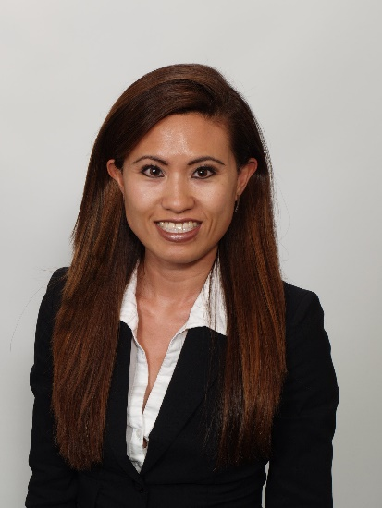

|  |  |
| --- | --- |
|  | **Annie Wu**  Attorney  20 Haight Street 415-673-4800 phone  San Francisco, CA 94102 415-771-5845 fax |

**Bio**

|  |  |
| --- | --- |
| Annie Wu has represented clients both on the plaintiff and defense side in civil litigation matters involving catastrophic injury, traumatic brain injury, wrongful death and insurance bad faith claims. Ms. Wu is an experienced trial lawyer and handled many cases involving multi-million dollar claims.  Before joining The Veen Firm, Ms. Wu represented corporate clients in toxic torts and products liability litigation. Her practice also includes premises liability, commercial transportation and trucking law, construction accidents and medical malpractice.  Ms. Wu earned her Bachelor of Arts degree from the University of Illinois in Urbana-Champaign, her Juris Doctorate from the University of San Diego School of Law and her Master of Business Administration degree from the University of San Diego School of Business.  In her spare time, Ms. Wu is actively involved in the community and volunteers for the Boys & Girls Clubs of San Francisco. | **EDUCATION**   * University of San Diego, School of Law * J.D. – 2004 * University of San Diego, School of Business * M.B.A. – 2009 * University of Illinois, Urbana-Champaign * B.A. – 2001   BAR ADMISSIONS   * California, 2004 * Illinois, 2005   AREAS OF PRACTICE   * Construction Accidents * Workplace Injuries * Personal Injury Accidents * Dangerous Property * Defective Products |

Speaking Engagements

* Western Trial Lawyers Association Maui Seminar: Pre-Trial Internet Focus Group, Speaker, June 2016
* SFTLA New Lawyers Division: Case Intake, Speaker, August 2015

Professional Associations and Memberships

* American Association for Justice, Member
* Consumer Attorneys of California, Member
* San Francisco Trial Lawyers Association, Member
* Santa Clara County Trial Lawyers, Member

Past Employment Positions

* Alexander Law Group, LLP
* Dehay & Elliston, LLP